**Reg. No. 21BCE1297 Name: Vidhi Shah Date of Practical: 13/04/22**

**Experiment 7**

**Aim:**

Study and simulation of MOSFET (Metal-Oxide Semiconductor Field-Effect Transistor) characteristics using LTSpice.

**Tools and Apparatus:**

­LTSpice, MOSFET Transistor, Resistors, Voltage Sources

**Theory and Design:**

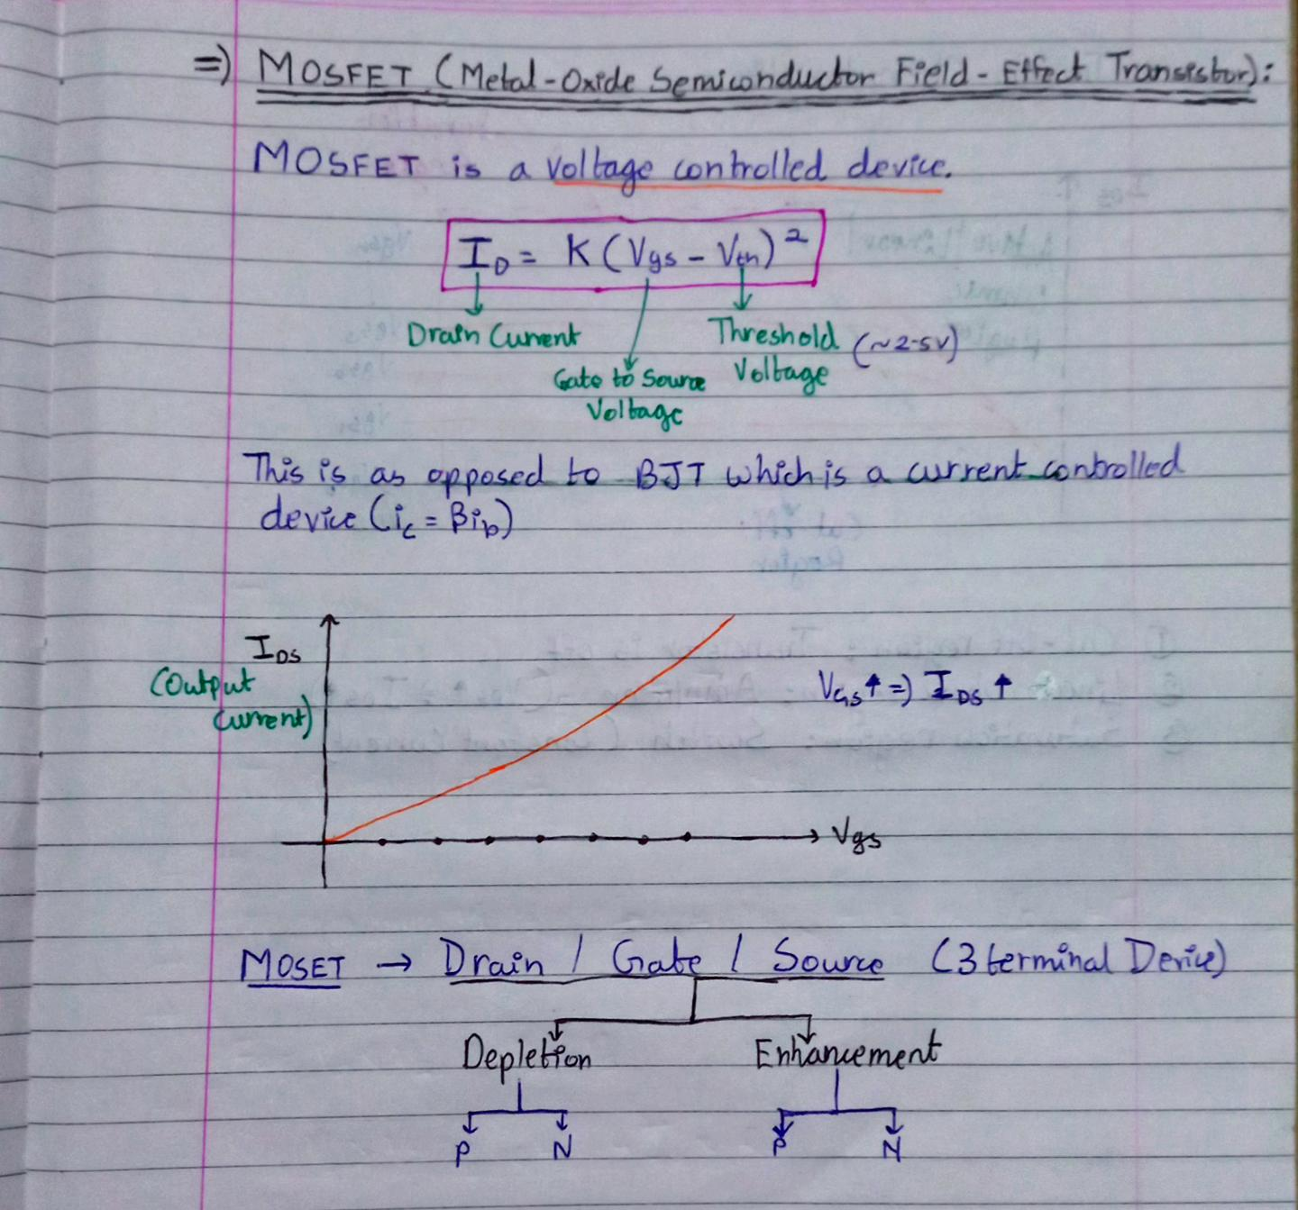

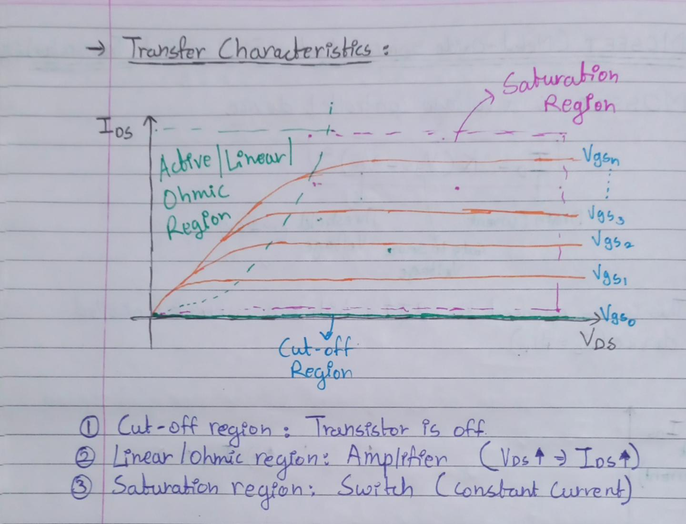

**Simulation Results:**

1. **Output Characteristics**

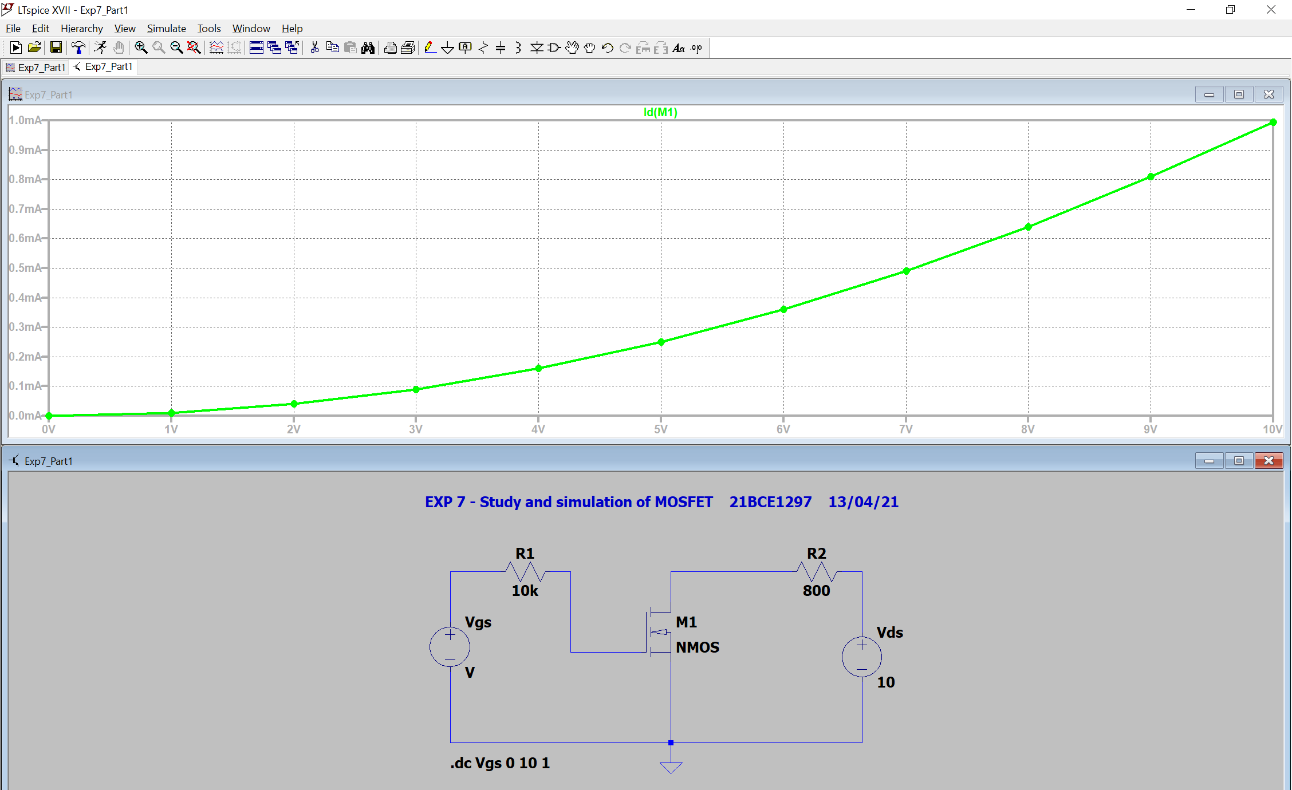

1. **Transfer Characteristics**

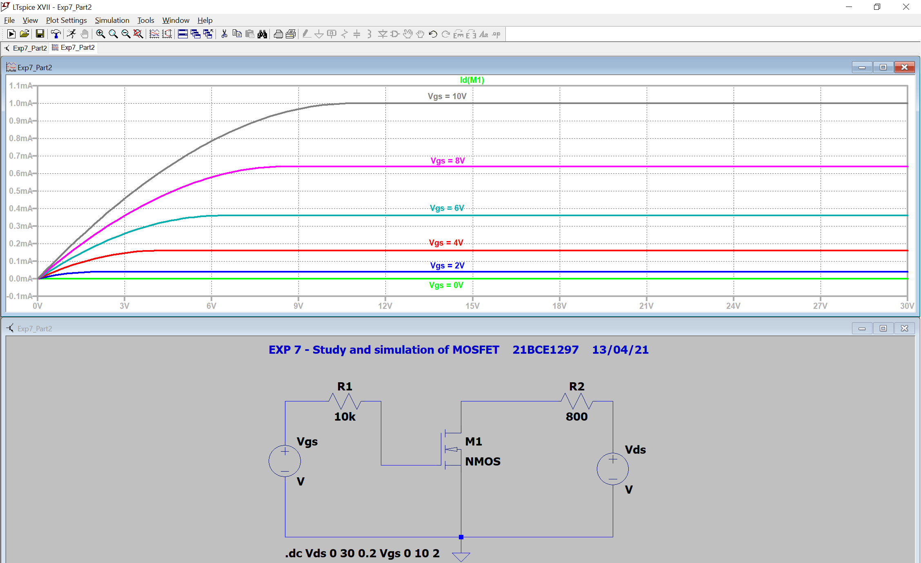

**Conclusion:**

1. **Output Characteristics:**

* IDS increases as VGS increases.

1. **Transfer Characteristics:**

* IDS increases linearly with respect to VDS in Active/Linear/Ohmic region.
* IDS remains constant with respect to VDS in Saturation region.

**Inferences:**

1. **IDS = K (VGS-VTH)2**
   1. Therefore, IDS increases as VGS increases in output characteristics of MOSFET
2. VGS = 0V is **Cut Off Region**:
   1. Transistor is in **off** state.
3. **Linear/Ohmic Region**:
   1. Transistor acts as an **amplifier** as **current increases** with increase in voltage
4. **Saturation Region**:
   1. Transistor acts as a **switch** as **current remains constant** with respect to voltage
5. In transfer characteristics keep first source as VDS and second source as VGS.